Nithin S
221IT085

IT253 Lab Assignment 1

Basic Linux Commands

1. Creating a file

Use touch command to create a file.

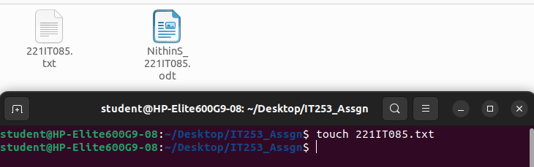

2. Write to a file

Use echo and cat command to write into a file.

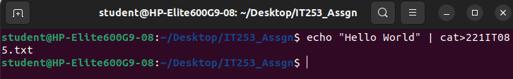

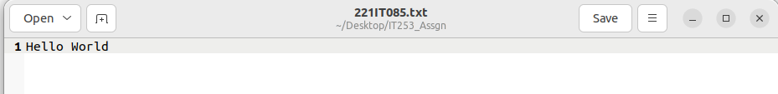

3. View contents of a file

Use cat command to view file content.

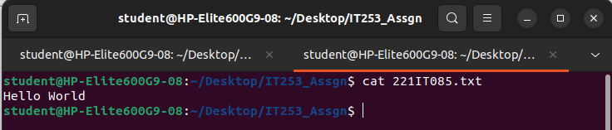

4. Copy content from one file to another

Use cp command

Syntax: cp spurceFile destinationFile

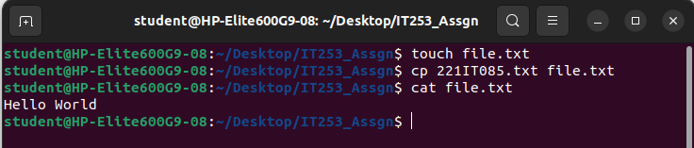

5. Renaming a file

Use mv command

Syntax: mv oldName newName

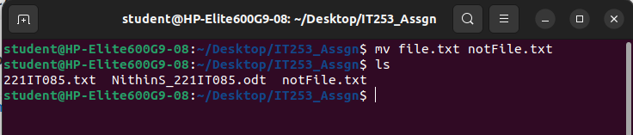

6. Removing a file

Use rm command

Syntax: rm fileName

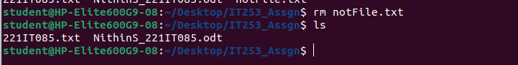

7. Creating a directory

Use mkdir command

Syntax: mkdir directoryName

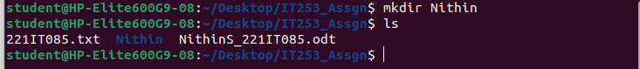

8. Moving files into a directory

Use mv command

Syntax: mv file1 file2 dir1

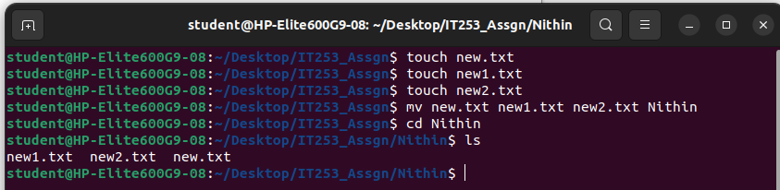

9. Copying files into a directory

Use cp command

Syntax: cp file1 file2 dir1

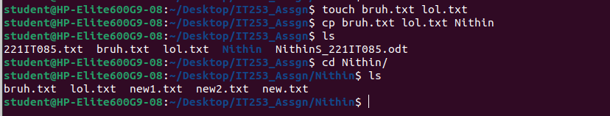

10. Rename a directory

Use mv command

Syntax: mv oldName newName

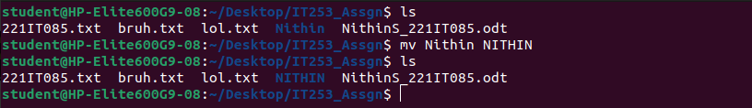
11. Copy files from one dir to another

Use cp command

Syntax: cp oldDir/* newDir
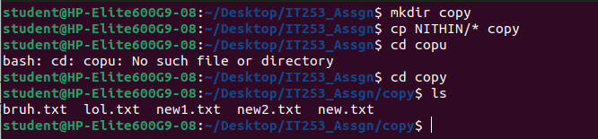

12. Move files from one dir to another

Use mv command

Syntax: mv oldDir/* newDir
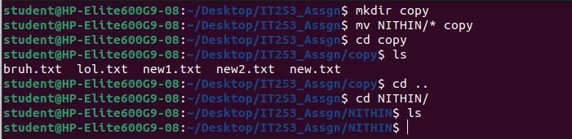

13. Remove a directory

Use rm – rf command

Syntax: rm -rf dirName

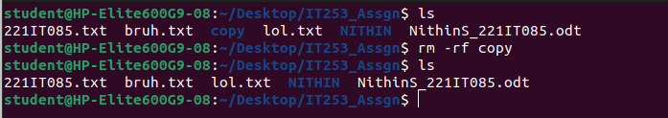

14. List contents of a directory

Use ls command in the directory of choice

Syntax: ls

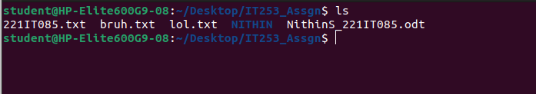

15. pwd

To know present working directory



16. cd

To change directory

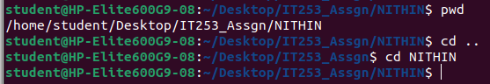

17. List Command Variations with flags

ls -a : list all files including hidden file starting with '.'
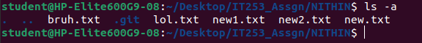
ls -d : list directories - with ' */'

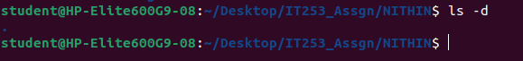

ls -F : add one char of */=>@| to enteries

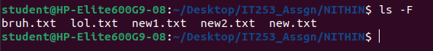

ls -l : list with long format - show permissions

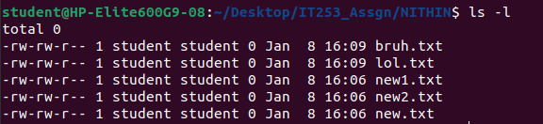

ls -i : list file's inode index number

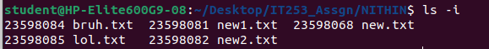

ls -s : list file sizes
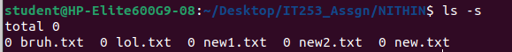
ls -t : sort by time & date
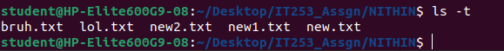
ls -S : sort by file size
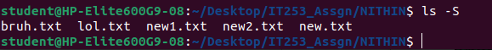
ls -r: list in reverse order
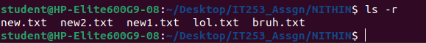

ls -ls: list with long format with file size
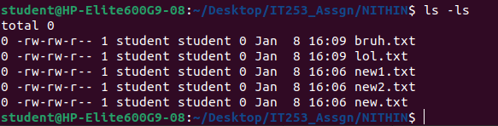
ls -lh: list long format with readable file size
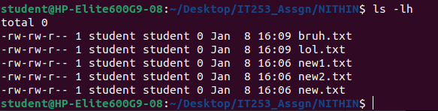
ls -la: list long format including hidden files
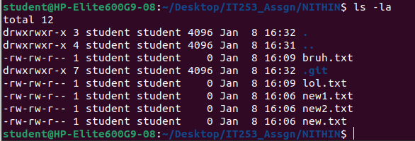
ls -X: sort by extension name
